To access PDF documents from Google Chrome
In the address bar type chrome:plugins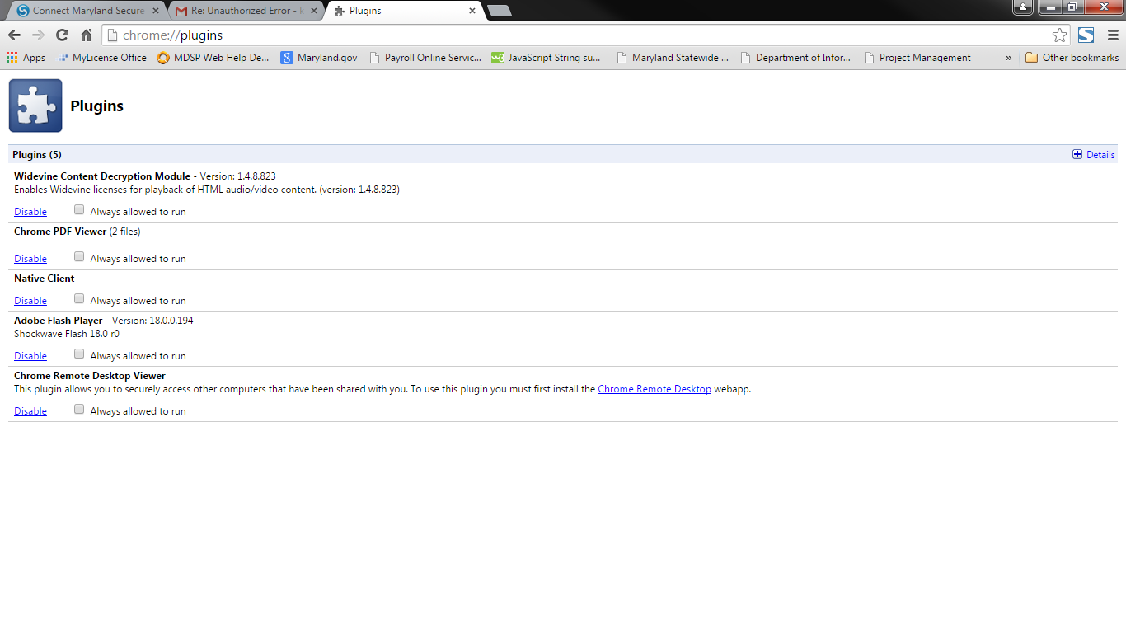
The PDF Viewer needs to be disabled in order to view PDFs. To disable the Chrome PDF Viewer click on the disable link under Chrome PDF Viewer.
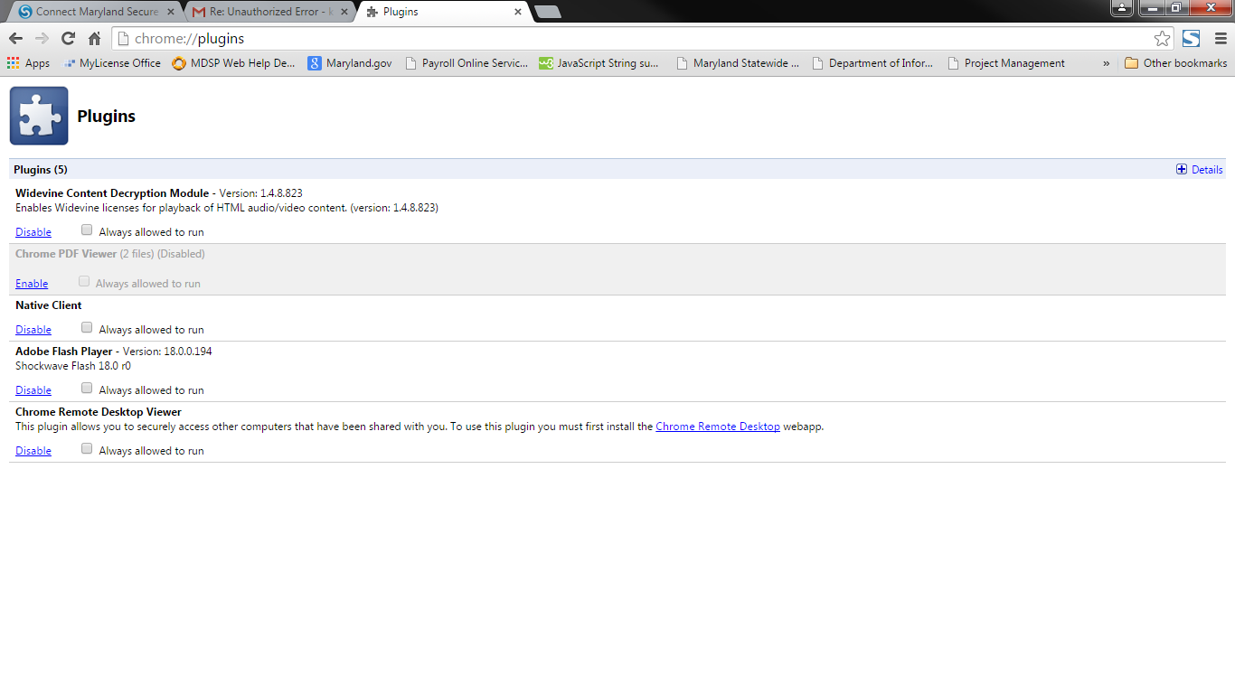
This is a one-time process once the Chrome PDF Viewer is disabled applications will be able to be downloaded.

